Question 1: Write a C program that adds two integer arrays A and B, each containing N elements, and stores the result in array C. Parallelize the addition using parallel for.
Answer:
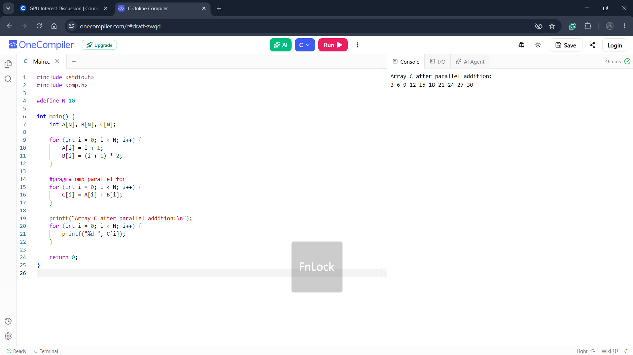

Question 2: Write a C program that calculates the sum and average of N floating-point numbers stored in an array. Identify the shared variable and parallelize it using reduction.
Answer:
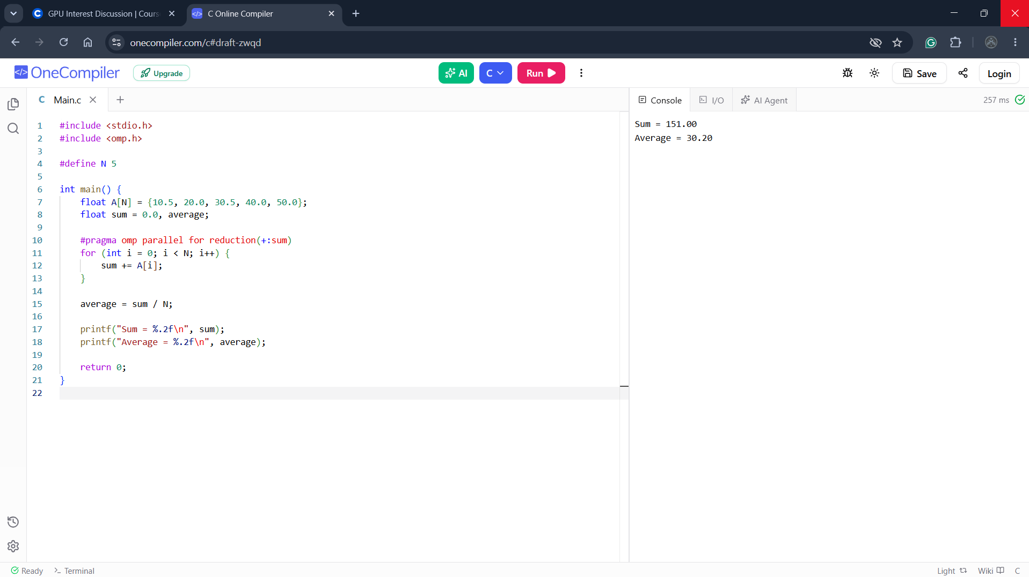
Question 3: Write a C program that finds the largest value in an integer array and reports its index.
Answer:
